

IoT Development

SD3A

CA2

Abiel Lopez

 Dillon Reilly

Erling Munguia

 Matthew Riddell

1. **System Architecture**

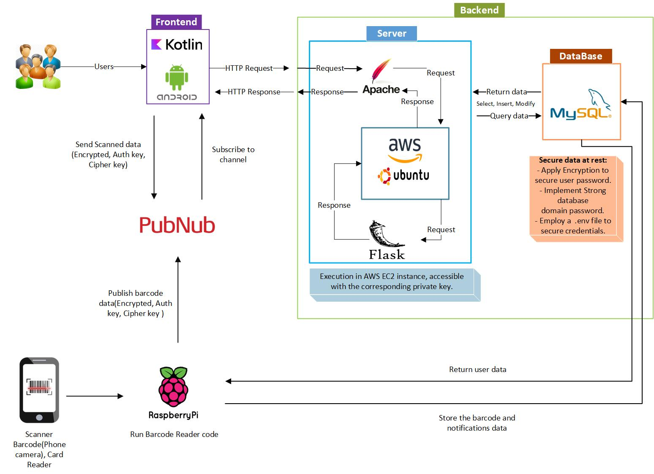

This Diagram was developed in Microsoft Visio, which is set out the System architecture of Care Connect Project. It displays a sequential structure of roles and interaction among all components. Where the user is the first to interact with the Frontend (Mobile App), which is the user interface. The Backend allocate the server side, the data processing and execute the response to Frontend requests. Also, it is integrated into the architecture PubNub, a cloud to demonstrate real time communication between the user and the server site. The key element to running the systems is the integration of Raspberry pi 4, directly connected to the Backend and making possible the functionality of the entire system.

**Fritzing Diagram:**

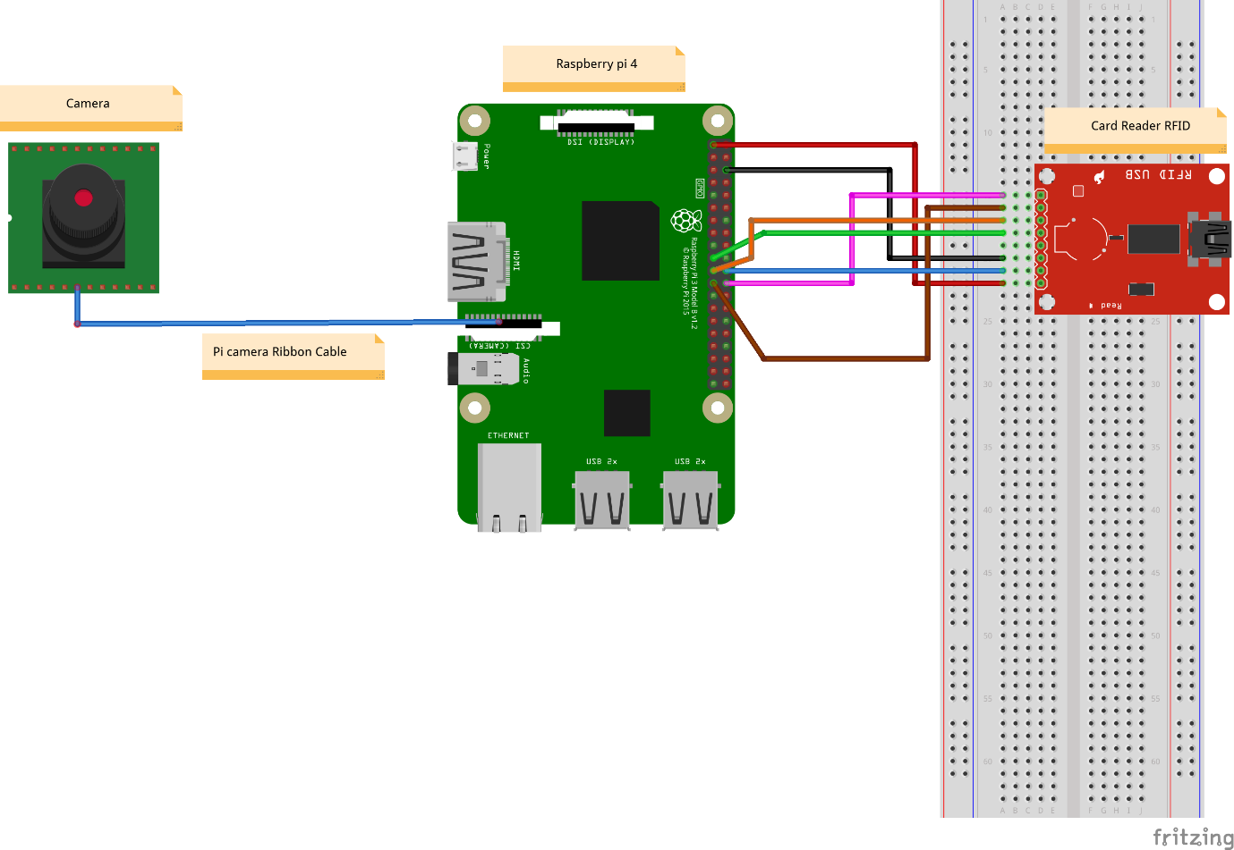

The Fritzing Diagram illustrates the connection between the raspberry pi 4, card reader RFID, and the camera using wires and a Ribbon cable. The camera plays the role as the QR code scanner (Mobile App is in development to perform and display the data read from the QR code). When a user taps their card on the card reader, and the associated data assign to that card is displayed.

1. **Alpha Prototype**
2. **Deploy to a cloud server**
3. **PubNub**

Section 2, 3 and 4 are specifically deployed on the server side, using AWS, raspberry pi 4. Evidence of the development is available on GitHub.

1. **Secure the application**